Dudka Daria
Front-end developer

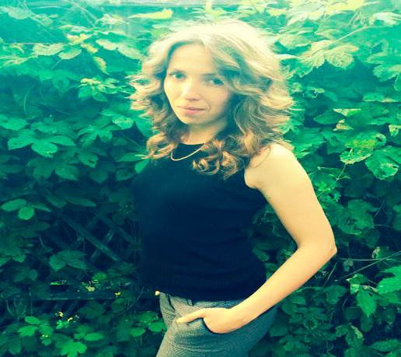
Personal information
Kharkiv
Tel: (099)-77-98-520
E-mail: jurr20@gmail.com

Knowledge and skills
- Skills in cross-browser layout, adaptive layout
- Experience with Photoshop
- Attention to detail and absolute focus on quality of work
- Ability to write standards-compliant code that works across browsers
- Pixel perfect
- Skills with Wordpress

Languages | Libraries | Environments
- HTML, HTML5  - CSS, CSS3 | - jQuery  - SASS/LESS  - Bootstrap | - OS: Windows 7  - IDE: Sublime Text 2

Employment History

06.2013 – 09.2013 (4 month): The conductor of passenger wagon
Responsibilities: - Passenger service and ensuring security
- The maintenance of internal and removable equipment of the wagon
- And a lot of other responsibilities concerning passenger comfort

20.04.2016 –now (3 month): Web-master
Responsibilities: - Create web-site using WordPress
- Finding information for the site
- Create a design for the site
- Work with ready-made templates
- Layout

Education

2011 - 2016: Ukrainian State University of Railway Transport
Organization of transportation and transport management

Courses:
- The conductor of passenger wagon
- Agent on a reception and sending of load and luggage
- Courses of Polish

Languages

Ukrainian – native
Russian – advanced
English – pre-intermediate
Polish - elementary

I am ready to learn a language in short terms if necessary

Personal qualities

Energetic: I am able to work long and hard hours
Quiet: I am a great listener
Meticulous: I pay attention to the small details
Resourceful: I use every tool at hand.
Self motivated, initiative, high level of energy
Tolerant and flexible to different situations

My works:
- http://shop.udc.org.ua/proektirovanie-2
- http://shop.udc.org.ua/kondicionirovanie
- http://shop.udc.org.ua/ventilyaciya-nabroski

